TIPS FOR AT-HOME READING
For many students, finding time and space to read at home can be hard! How can we support our children by creating a lifelong love of learning and reading? How can we spend time together as a family engaging in reading activities? How can it help our student’s social and emotional growth and well-being by exploring issues and talking about difficult topics through other people or characters?

Practice Good Habits  - Positively model being a reader.  - Have lots of reading materials at home.  - Provide time and opportunities to read.  - Be mindful of screen time (computer, phone, video games, etc.).  - Take a trip to the library or visit online: https://library.nashville.org  - Help your student choose his/her own books.  - Look for reading materials related to your family history or culture.  - If your student is bilingual, encourage reading in both languages.  - Use the Closed Caption option on your TV.  - Talk to your student’s teachers or librarians about reading and books options.  - If your student has difficulty reading, talk to his/her teacher immediately.  Talk Together  Questions to Ask About Literature  - What happened?  - What makes you think that?  - How do you know?  - Make a prediction. What do you think will happen next?  - What was your favorite part or character? Why?  - If you could change a part, what would you change and why?  - Why is the title a good one for this story?  - What words (or pictures) in the story stood out to you? Why? What do you think ___ meant?  Questions to Ask About Informational Texts  - What is this text about?  - What do you think the author wanted you to  learn about this topic?  - What is the main idea of this text? | Read Together  Read/Watch at Home  - Picture Book  - Novel  - News article  - Magazine  - Comic  - Recipe  - Movie  - TV Show  - Blog  How to Engage Children in Reading  - Setup a cozy, quiet, and inviting space  - Younger students: take turns reading aloud: child reads to adult, adult reads to child, siblings read to each other  - Older students: read silently near each other  Do Tasks Together  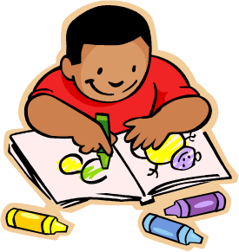  Fun Things to Do After Reading  - Discuss the text.  - Retell the story.  - Draw a picture related to the text.  - Write a different ending or continue the story.  - Write a letter or postcard to the author.  - Research more about the topics.  - Make a list of Fun Facts or “Did you know?" cards.  - Create a collage to represent your favorite character.  - Act out a scene from the book or turn the book into a TV episode.  - Create a blog review of the book.  - Join a book club (like ProjectLit) to discuss with peers.
The Metropolitan Nashville Public Schools (MNPS) does not discriminate on the basis of race, religion, creed, gender, gender identity, sexual orientation, national origin, color, age and/or disability in admission to, access to, or operation of its programs, services, or activities. MNPS does not discriminate in its hiring or employment practices.

